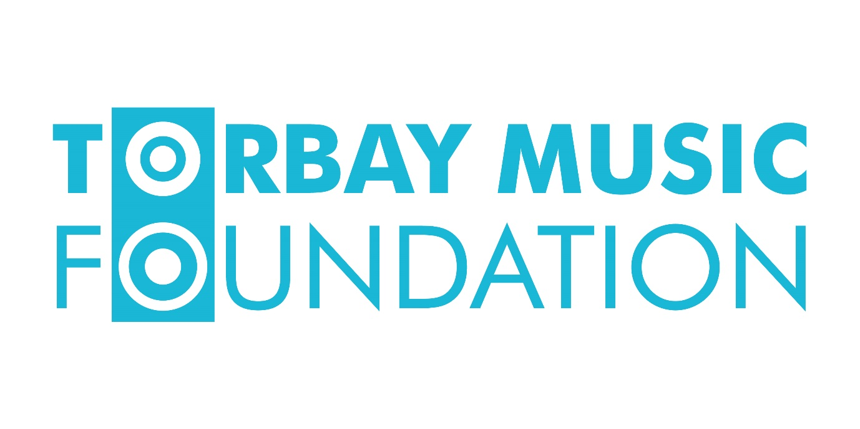
Trustee Recruitment Pack
Thank you for showing an interest in becoming a trustee for Torbay Music Foundation
We are currently in the process of setting up a brand new Charitable Incorporated Organisation (CIO) called the Torbay Music Foundation. The objective of the Foundation will be ‘For the public benefit, fundraising to provide music education opportunities for Torbay’s young people who would otherwise be unable to benefit’ As a new charity, this is an exciting opportunity to share in our values and vision to help the charity grow into a creative and dynamic organisation which puts young people at the heart of everything it does. We are looking for motivated individuals from a range of different backgrounds to form a first-class board of trustees, which offers a broad, complementary mix of skills and experience. We are particularly keen to recruit trustees with a fundraising background, or experience in setting up or working within a very new charity. All other skill sets will be considered. You will get the chance to shape Torbay Music Foundation as it starts up, develops working practices and grows.
Torbay Music Foundation will be a charity, fundraising to provide music education opportunities for Torbay’s young people who would otherwise be unable to benefit. Working in close partnership with Torbay Music Hub, the charity will strive to further the Core and Additional Roles of the National Plan for Music Education (2011), which the Hub works to.

Music is often seen as the preserve of the rich/middle class. We want to break down those perceptions and ensure that all children and families are able to access musical activity. Every child can benefit from music education in many ways. Music connects the brain in ways no other subject can. It enables children to develop skills such as: listening, memory; perseverance/resilience; and self-expression as well as providing benefits to physical health and wellbeing. All children have the right to access these benefits.

Torbay Music Hub provides all pupils in Torbay with the opportunity to learn to play an instrument, to sing, to participate in major events, to experience live music, take part in choirs and ensembles etc. However, for most students, that initial experience in school cannot be built upon due to family financial pressures. Torbay Music Hub can provide bursaries for many students who meet the criteria for Pupil Premium. There are, however, many more, hard-working, families who are unable to afford music opportunities (e.g. instrumental lessons, attendance at music groups etc). The Torbay Music Foundation will work to raise funds to enable more children to access these musical opportunities.

Responsibilities of the role
The trustees will work with the Chair to take overall responsibility for Torbay Music Foundation, acting collectively in its best interests by giving strategic direction and determining its mission and vision. We aim that the Board of Trustees will comprise of eight members: Chair, Treasurer, Secretary and four trustees along with a non-voting ex-officio trustee who has already been appointed.
To help Torbay Music Foundation set its strategic focus with clear goals and objectives, we are particularly keen to recruit people with experience and skills in the following areas:

- charity work
- fundraising
- governance
- event planning
- business strategy
- finance

In addition to any special areas of expertise you may be able to contribute, the duties of a trustee are:

- to ensure the organisation complies with its governing document, charitable law and any other relevant legislation or regulations
- to ensure the organisation pursues its objectives as defined in its governing document and applies its resources exclusively in fulfilling its objectives
- to contribute actively to the board by giving strategic direction to the organisation, setting overall policy and defining goals and targets
- to safeguard the good name and values of the organisation and to represent the organisation at functions and meetings as appropriate
- to be collectively responsible for the actions of the organisation and other trustees, while ensuring the effective and efficient administration of the organisation
- to ensure the financial stability of the organisation
- to make sure the organisation is properly insured against all reasonable liabilities
- to declare any conflict of interest while carrying out the duties of a trustee

In addition to the above statutory duties of all trustees, each trustee should use any specific knowledge or experience they may have to help the board reach sound decisions. This will involve scrutinising board papers, leading discussions, focussing on key issues, and providing advice and guidance as requested by the board on new initiatives, or other issues relevant to the area of the organisation’s work in which the trustee has special expertise

- to attend meetings, sub-committee meetings, and to read papers in advance of meetings
- to participate in other tasks that arise from time to time, such as interviewing new staff, helping with fundraising, representing the charity at events
- to keep informed about the activities of the organisation and wider issues which affect its work.

The Charity Commission, our regulatory body, has a wealth of information about being a trustee, including its guide to the six main duties of a trustee, which can be found at
www.gov.uk/guidance/charity-trustee-whats-involved

Eligibility Criteria
Before you consider applying for the role, please read the following to ensure you meet our eligibility criteria. You must be at least 16 to be a trustee of a charity, at least one of the trustees must be aged over 18. You must be properly appointed following the charity’s governing document procedures.

You must not act as a trustee if you are disqualified on the following grounds, unless authorised to do so by a waiver from the Charity Commission:

- having an unspent conviction for an offence involving dishonesty, you are on the sex offenders register, deception (such as fraud), terrorism or money laundering
- being bankrupt, or entering into a formal arrangement (e.g. an individual voluntary arrangement) with a creditor
- removal as a company director or charity trustee because of wrongdoing.

We want the organisation to be as representative as possible of the community it serves. We consider diversity to embody a wide range of life experiences, work experiences, perspectives, cultures, ethnicity, gender, age, disability, religion, class, sexual orientation and other aspects of life. We therefore welcome and encourage applications from people of all backgrounds. We are committed to ensuring that all trustee applicants are treated fairly and with respect, irrespective of their background including gender, sexual orientation, marital status, age and race (including colour, nationality and ethnic origin), religion/belief or disability.

Term and Time Commitment
- the time commitment for a trustee is expected to be up to a day a month
- for initial appointments to the board, the terms of office will be staggered between 1 year and 3 years in length to ease recruitment pressures in future years.
- trustees under the age of 18 will have a maximum term of 1 year with a possible further three extensions of 1 year, upon application
- after initial recruitment, terms for trustees aged over 18 will be for a maximum term of 3 years with a possible further three extensions of 1 year, upon application
- there will be a six-month trustee probation period
- the board meets up to six times a year, with additional operational meetings and sub-groups as necessary
- trustees are expected to plan to attend board meetings in person
- board meetings will take place at a range of times including day time and evening meetings
- in addition to board meetings, other contact – usually by email/phone – will be necessary
- trustees are expected to make a regular commitment to additional meetings/events as needed
- trustees may be asked to attend occasional evening meetings and events as a representative of the charity.

Remuneration: The role of trustee is voluntary, however, reasonable out of pocket expenses will be reimbursed. The time commitment for a trustee is expected to be up to a day a month

Skills and Competencies
Below are examples of the sorts of knowledge and experience we are looking for. No individual is expected to possess all of the below. They will be covered by the complementary skillset of all the trustees. Successful boards are about finding a balance of skills, knowledge and experience from a mix of individuals with a wide range of backgrounds:

Knowledge and Experience
- an understanding of the role of a trustee and corporate board member
- experience of operating in a senior role
- experience of fundraising and/or bid-writing
- broad knowledge of management and governance issues
- an understanding of the work of the voluntary and community sectors

Skills
- a strategic thinker
- business acumen, particularly experience with early or mid-stage entrepreneurial organisations
- a sharp mind who exercises good judgement
- an effective communicator proactive, willing to offer constructive challenge and support judgements
- a team player who respects different views and is able to work with board colleagues
- an ability to build strong relationships and champion Torbay Music Foundation
- understanding/experience in bid-writing
- Financy/accounting – Ideally experience in the development and use of business/charity financial reporting or management accounts or budgeting & cash flow.

Personal Qualities
- demonstrates drive and determination
- entrepreneurial flair
- strategic vision
- commitment to the values and objectives of Torbay Music Foundation
- brings the commitment necessary to devote sufficient time, preparation and effort required to meet the responsibilities of being a trustee
- demonstrates integrity, honesty and flexibility
- demonstrates active listening skills and is open to the views of others
- commitment to inclusion and diversity.

We hope you have found this interesting and are considering applying for the role of trustee for Torbay Music Foundation. We are passionate about giving all the young people of Torbay the opportunity to access musical education. As a new charity it is crucial for us to find the right trustees who share our enthusiasm, commitment and vision. Please note successful candidates will be subject to a DBS check.

Apply now by sending your CV with covering letter to tms@torbay.gov.uk
Applications close on 22nd April 2019

